|  |  |
| --- | --- |
|  | **FPT ACADEMY INTERNATIONAL**  **FPT – APTECH COMPUTER EDUCATION** |

**Centre Name: ACE-HCMC-2-FPT.**

**Address: 590 Cach Mang Thang 8, District 3, Ho Chi Minh City, Viet Nam.**

**BARBERIA**

|  |  |  |
| --- | --- | --- |
| **Supervisor:** | Mr. Ngo Phuoc Nguyen | |
| **Semester:** | IV | |
| **Batch No:** | ACCP 6715 | |
| **Group No:** | 1 | |
| **Order:** | **Full name** | **Roll No.** |
| 1. | Le Minh | Student1225645 |
| 2. | Nguyen Minh Thoai | Student1225526 |
| 3. | Hoang Thien An | Student1198581 |
| 4. | Luong Vinh Hien | Student1204494 |

July 2021

|  |  |
| --- | --- |
|  | **FPT ACADEMY INTERNATIONAL**  **FPT – APTECH COMPUTER EDUCATION** |

REVIEW 1

# Introduction

The purpose of this document is to present a detailed description of a Barber Shop Booking System. It will explain the purpose and feature of the system, the interfaces of the system, what the system will do. Furthermore, this document also explains the potential in the future for small business. However, in this project will only working on one single Barber Shop that has many branches.

This application can be improve multiple shops for large business and small business.

# Application Description

1. **For guests who book online**

_        Appointments can be made via phone number without registration

_        Guests can register and make an appointment

_        Guests who sign up can see the appointment time

_        Guests can change their nickname

_        Subscribers can see appointment history

_        Guests arrive at the shop 10 minutes in advance to be checked into the system by the staff

_        Guests arriving at the salon after the appointment will cancel the appointment

1. **For current visitors**

_        Visitors to the shop will be checked into the system by the staff

1. **For staff and managers in the salon**

_        Manage login to browser

_        Login staff can view personal information

_        In the early hours of work, employees will checkin (or check-in)

_        End of work the employee will checkout (checkout)

_        View guest appointment list online

_        Checkin for guests upon arrival at the salon

_        Staff arrangements for guests

_        Make payments to guests

**4. For Admin and Management**

_        Login to admin page

_        Branch Management (CRUD)

_        Employee Management (CRUD) - <<Create an account for an employee>>

_        Service Management (CRUD)

_        Manage customer lists

_        Manage appointment history

_        Report Management

~~_        Employee payroll management~~

1. **Tables Design**

## Salon (info)

|  |  |  |
| --- | --- | --- |
| **id** | int | **PK** |
| **salon_name** | Varchar(200) |  |
| **address** | Varchar(200) |  |
| **email** | Varchar(200) |  |
| **Thumbnail_url** | Varchar(200) |  |
| **phone_number** | Varchar(100) |  |
| **opening_hour** | Time |  |
| **minute_in_one_time_slot** | int |  |
| **is_available_for_online_booking** | bit |  |
| **number_of_turn_in_one_time_slot** | int |  |
| **is_opened** | bit |  |
| **is_car_parking_available** | bit |  |

## Employee

|  |  |  |
| --- | --- | --- |
| **id** | Long | **PK** |
| **Nick_name** | Varchar(100) |  |
| **phone_number** | Varchar(100) |  |
| **password** | Varchar(255) |  |
| **first_name** | Varchar(100) |  |
| **last_name** | Varchar(100) |  |
| **role** | Varchar(50) |  |
| **gender** | bit |  |
| **salon_id** | Long | FK |
| **Thumbnail_url** | Varchar(200) |  |
| **is_active** | bit |  |
| **email** | Varchar(200) |  |
| **home_address** | Varchar(200) |  |
| **date_of_birth** | Date |  |
| **is_online_booking_available** | bit |  |
|  |  |  |

## Customer

|  |  |  |
| --- | --- | --- |
| **id** | Long | **PK** |
| **phone_number** | Varchar(100) |  |
| **password** | Varchar(255) |  |
| **nick_name** | Varchar(100) |  |
| **email** | Varchar(200) |  |
| **Is_membership** | bit |  |
| **Membership_name** | Varchar(100) |  |

## Service

|  |  |  |
| --- | --- | --- |
| **id** | Long | **PK** |
| **service_name** | Varchar(100) |  |
| **original_price** | double |  |
| **time_consume** | int |  |
| **is_discount** | bit |  |
| **discount_price** | double |  |
| **description** | Varchar(300) |  |

## Booking

|  |  |  |
| --- | --- | --- |
| **id** | Long | **PK** |
| **customer_id** | Long | FK |
| **Salon_id** | Long | FK |
| **chosen_time_slot** | Timestamp |  |
| **description** | String |  |
| **employee_id** (optional) | Long | FK |

## Booking details

|  |  |  |
| --- | --- | --- |
| **id** | Long | **PK** |
| **booking_id** | Long | FK |
| **service_id** | Long | FK |

## Turn

|  |  |  |
| --- | --- | --- |
| **id** | Long | **PK** |
| **employee_id** | Long | FK |
| **booking _id** | Long | FK |

## Payment

|  |  |  |
| --- | --- | --- |
| **id** | Long | **PK** |
| **turn_id** | Long | FK |
| **total_price** | double |  |
| **payment_method** | Varchar(100) |  |

## Feedback

|  |  |  |
| --- | --- | --- |
| **id** | Long | **PK** |
| **Full_name** | Varchar(100) |  |
| **email** | Varchar(255) |  |
| **Phone_number** | Varchar(100) |  |
| **comment** | Varchar(300) |  |
|  |  |  |

## Hair_style

|  |  |  |
| --- | --- | --- |
| **Id** | Long | **PK** |
| **title** | Varchar(200) |  |
| **Desciption** | Text(30000) |  |
| **thumbnail** | BLOB |  |

# Function Includes

* Admin login system
* Security – Authentication and Authorization
* Jason Web Token (JWT)
* Booking system
* Payment method (credit card and cash)
* Payment with MOMO wallet
* Reports printing

# Modules

* **Visitors** (Customer without registry)
* **Registered** **Users** (Customer)
* **Administrator** (Employee)
* **Stylists** (Employee)

1. **Visitor modules**

* View salon information
* Sending message to Admin
* Register new account
* Making booking online
* Making a feedback

1. **Registered** **Users** **modules**
   * Add their nickname
   * Edit their nickname
   * Making booking online
   * Change password
   * View booking detail
   * View booking history
   * Delete booking history
   * Rating stylist
   * Add complaint
   * Edit complaint
2. **Stylist Modules**

**ROLE_STAFF**

* Check-in
* Update personal information
* Change password
* Take turn with booking
* View, update their information
* View their history turn
* View amount they make
* View booking list
* View personal salary
* Contact to manager
* Making payment

**ROLE_MANAGER**

* Check-in
* Update personal information
* Change password
* Take turn with booking
* View personal information
* View their history turn
* View amount they make
* View booking list
* View personal salary
* View all staff salary
* View all staff information
* Login to Admin page
* Contact to Admin
* View feedback
* Making payment

1. **Administrator Modules**

**ROLE_ADMIN**

* + Login to Admin page
  + Register new employee
  + New Admin
  + Mange feedback
  + Edit role of the employee
  + View employee information
  + Edit employee information
  + Delete employee
  + View reports
  + View employee work-days
  + Sending email to employee
  + Change password
  + Add new salon location
  + Update salon information

# Naming Conventions

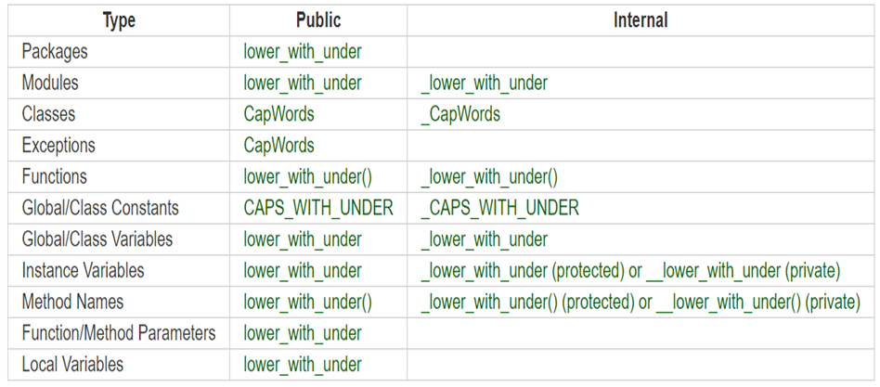

# Technologies And Versions

* **TECHNOLOGIES**
* Spring boot framework
* HTML/CSS
* JavaScript
* Reactjs
* Redux
* React-redux
* Jquery
* **BACK-END**
* SDK 1.8 version 1.8.0_291
* Java 8
* Web API: Spring-boot 2.5.1 (Maven)
* **FRONT-END**
* REACTJS + REACT-REDUX
* NODEJS version 14.17.0 LTS
* ADMIN_PAGE
* REACT-REDUX
* Template: AdminLTE v3.1.0
* Bootstrap version 4.6.0
* CLIENT_PAGE AND EMPLOYEE_PAGE
* React-redux
* Template: <https://www.free-css.com/free-css-templates/page253/style-barber>
* Bootstrap version v4.1.0
* **DATABASE**
* MySQL 8.0
* MySQL Workbench 8.0 CE

# Hardware And Software Requirements

* **Server Requirement**
* **Hardware**

|  |  |
| --- | --- |
| **Component** | **Requirement** |
| **CPU** | Processor type:  Pentium IV-compatible processor or faster  Processor speed:  Recommended: 2.0 GHz or faster |
| **OS** | Microsoft Windows Server 2012 with IIS |
| **Memory (RAM)** | RAM:  Minimum: 512 MB  Recommended: 2 GB or more |
| **Hard Drive** | Free space:  Minimum: 200 MB  Recommended: 50 GB or more  Maximum: Operating system maximum |

* **Software**

|  |  |
| --- | --- |
| **Component** | **Requirement** |
| **RDBMS** | MySQL 8.0 |
| **DATABASE UI** | MySQL Workbench 8.0 CE |
| **IDE** | IntelliJ IDEA Community |

* **Client Requirement**
* **Hardware**

|  |  |
| --- | --- |
| **Component** | **Requirement** |
| **CPU** | Processor type:  Pentium III-compatible processor or faster  Processor speed:  Recommended: 1.0 GHz or faster |
| **OS** | All OS (Window, Linux, Android, Mac OS …) |
| **Memory (RAM)** | RAM:  Minimum: 512 MB  Recommended: 1 GB or more  Maximum: Operating system maximum |
| **Hard Drive** | Free space:  Minimum: 10 MB |

* **Software**

|  |  |
| --- | --- |
| **Component** | **Requirement** |
| **Web Browser** | Chrome, Opera (up to date) |

# Architecture And The Design Of The Project

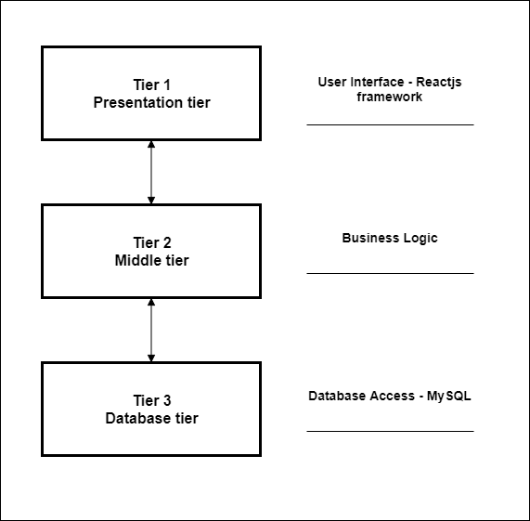

***Task Sheet 1***

|  |  |  |  |  |  |  |  |
| --- | --- | --- | --- | --- | --- | --- | --- |
| **Project Ref. No.:**  **BARBERIA** | | **Project Title:** | **Activity Plan Prepared By:** | **Date of Preparation of Activity Plan:** | | | |
| **Sr.No.** | **Task** | **Actual Start Date** | **Actual Days** | **Team Mate Names** | **Status** |
| 1 | Introduction and Problem Definition | **BARBERIA** | **Le Minh** | 12/07/2021 | 5 | **All Members** | 100% |
| 2 | Application Description | 12/07/2021 | 5 | 100% |
| 3 | Table Design | 12/07/2021 | 5 | 100% |
| 4 | System Requirement Specification |
| 5 | Architecture |

REVIEW 2

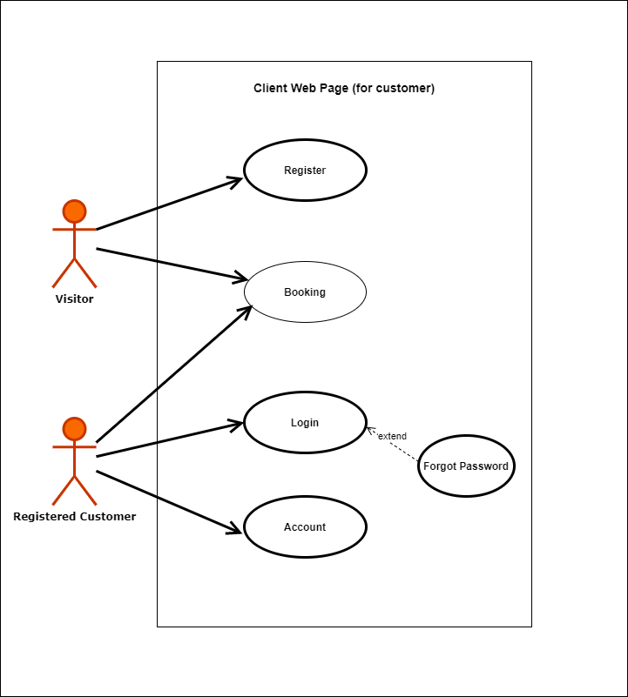

# Use Case

## **Client with Registry and Client without Registry**

1. **Staff & Man**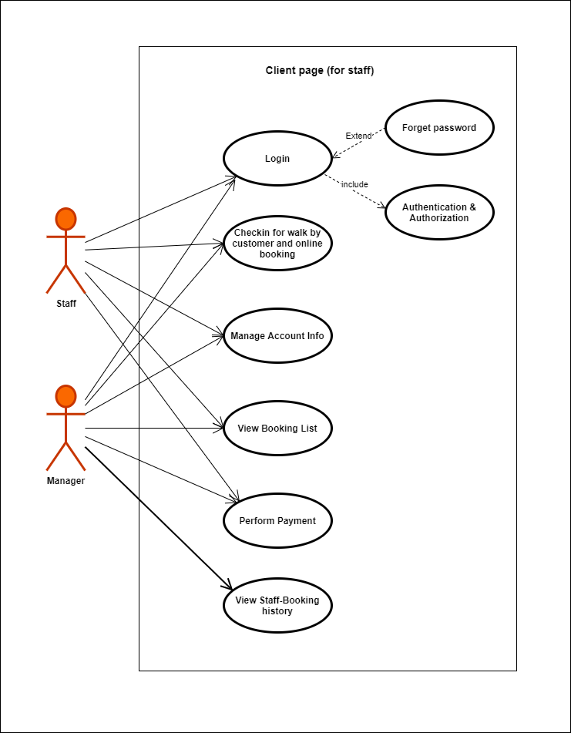

## **Admin & Manager**

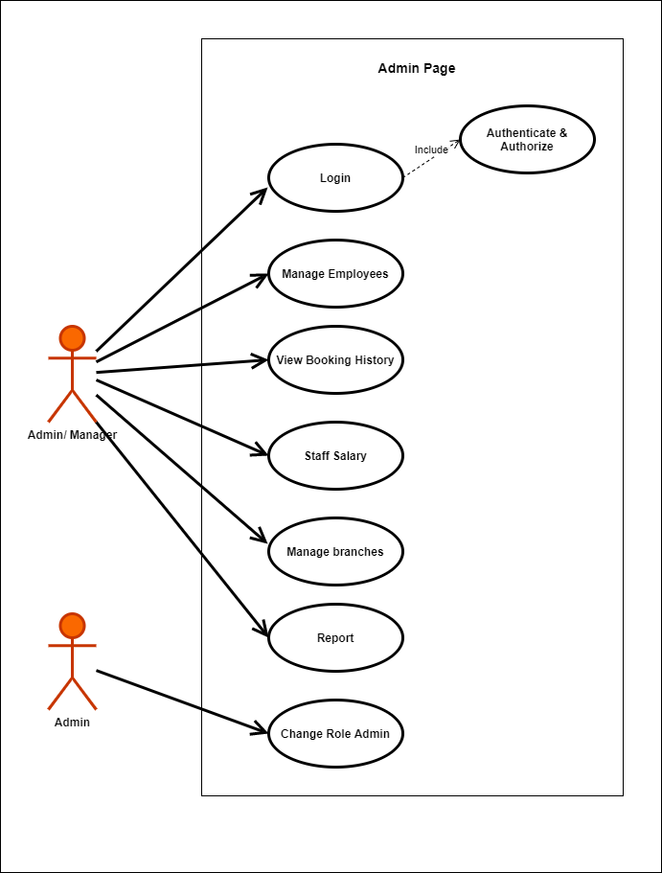

# ERD

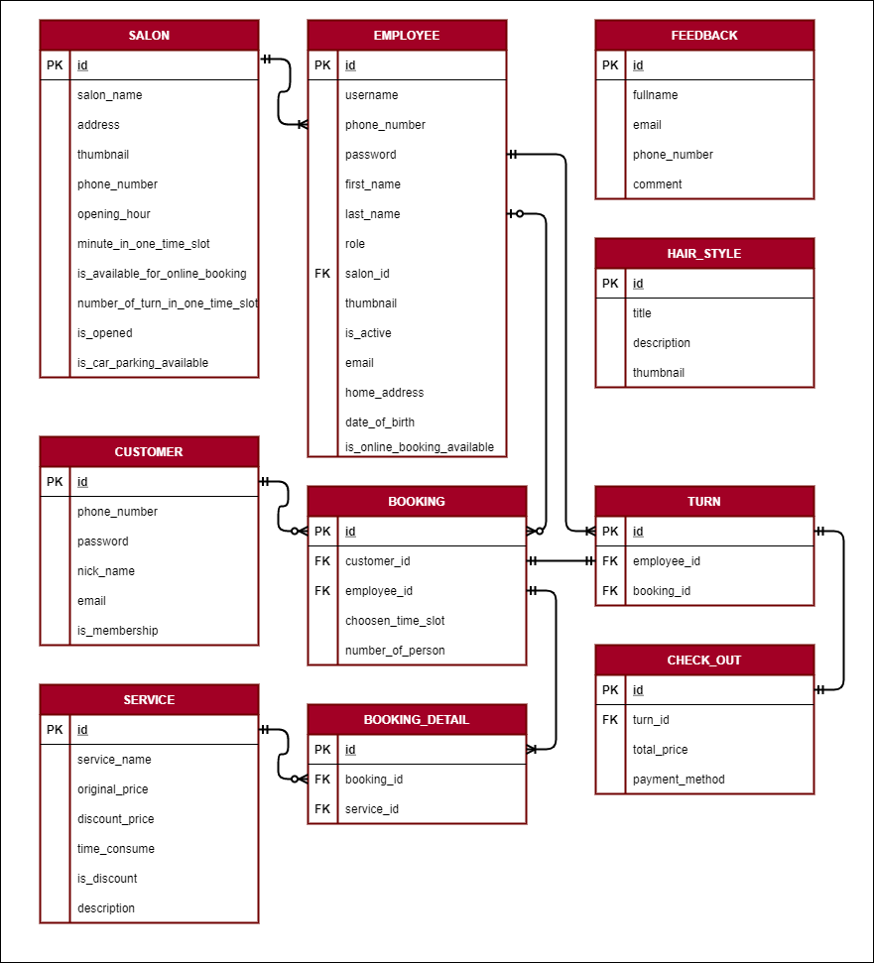

# Data Flow Diagrams (DFDs)

## **Context Diagram (Level 0)**

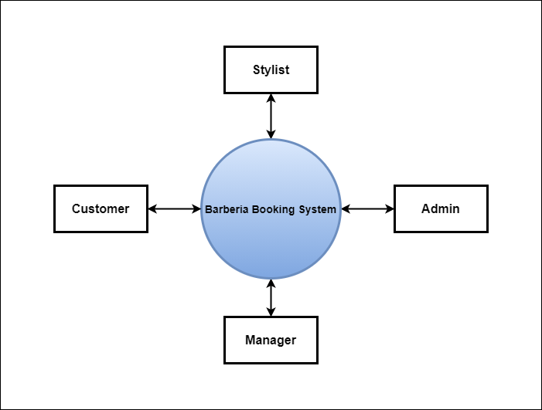

## **Level 1**

# Sequence Diagrams

## **Visitor**

* 1. **View salon information**

|  |  |  |
| --- | --- | --- |
| **Author** | Luong Vinh Hien | |
| **Use Case Name** | View salon information | |
| **Actors** | Visitor | |
| **Description** | The visitor can view all information of salon | |
|  | **Actor Action** | **System Responses** |
| **Basic Flow** | Step 1: Click on Salon | Step 2: Display all details |
| **Alterative flow** | Step 3: Visitor can check location, open hour, image, number of staff…. |  |

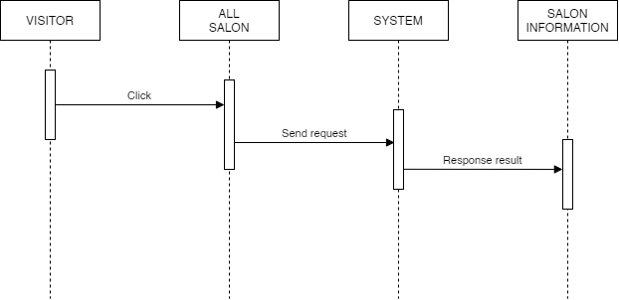

* 1. **Sending message to Admin**

|  |  |  |
| --- | --- | --- |
| **Author** | Luong Vinh Hien | |
| **Use Case Name** | Sending message to Admin | |
| **Actors** | Visitor | |
| **Description** | Visitor can send the message to Admin | |
|  | **Actor Action** | **System Responses** |
| **Basic Flow** | Step 1: Click “Send Message” | Step 2: Add the message to data |
| **Alterative flow** | Step 3: Visitor can send the question, time, service…. |  |

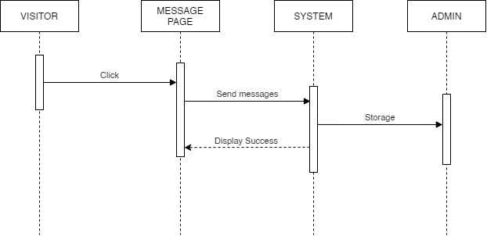

* 1. **Register new account**

|  |  |  |
| --- | --- | --- |
| **Author** | Luong Vinh Hien | |
| **Use Case Name** | Register new account | |
| **Actors** | Visitor | |
| **Description** | Visitor can register all personal information and becomes a member | |
|  | **Actor Action** | **System Responses** |
| **Basic Flow** | Step 1: Input information: Name, Email, Cellphone, Address, Password, Confirm password and click on Submit button | Step 2: Check the information  Step 3: Create customer account  Step 4: Show message to go to login screen. |
| **Alterative flow** | Step 3: Visitor can register with their information to get loyaty score, promotion or news of new trend. |  |

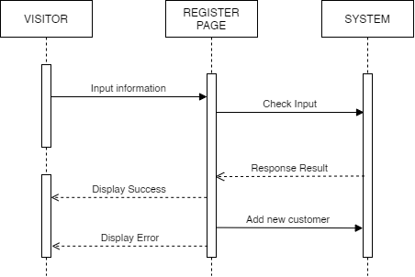

## **Registered user**

* 1. **Add, edit nickname**

|  |  |  |
| --- | --- | --- |
| **Author** | Hoang Thien An | |
| **Use Case Name** | Add nickname / Edit nickname | |
| **Actors** | Registered Users | |
| **Description** | Registered Users can add or edit their nicknames to support easier contact | |
|  | **Actor Action** | **System Responses** |
| **Basic Flow** | 1.User click on add nickname or edit nickname in the dropdown list of phone number  3. Click Save button after changing nickname | 2. Redirect to Add nickname or Edit nickname page. Edit page will show the nickname in use  4. The data will be saved into database |
| **Alterative flow** |  |  |

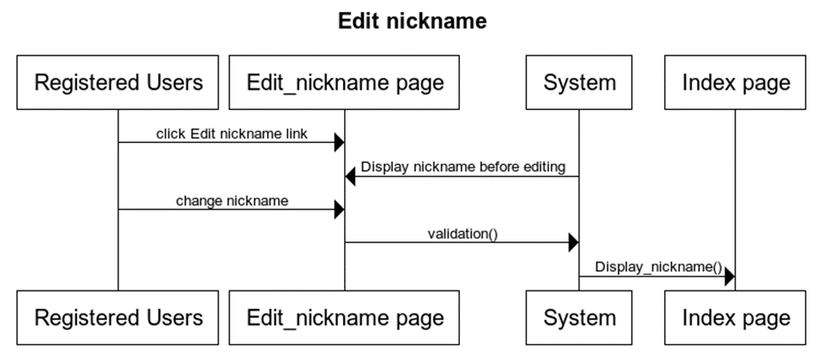

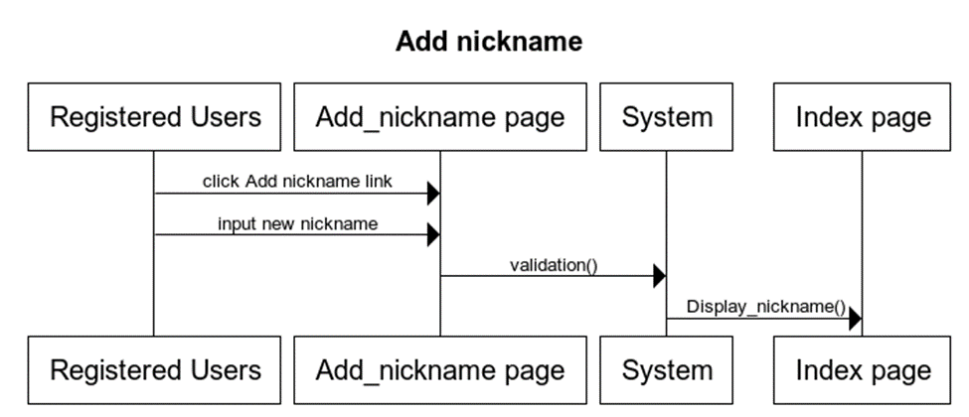

* 1. **Making Booking online**

|  |  |  |
| --- | --- | --- |
| **Author** | Hoang Thien An | |
| **Use Case Name** | Making booking online | |
| **Actors** | Registered Users | |
| **Description** | Registered Users can also making booking online like visitor | |
|  | **Actor Action** | **System Responses** |
| **Basic Flow** | 1. User click on Booking now button to make booking online  3. User make selection and click complete button | 2. Redirect to Booking page, show barber shop list, services, timetable.  4. The booking information will be forwarded to admin |
| **Alterative flow** |  |  |

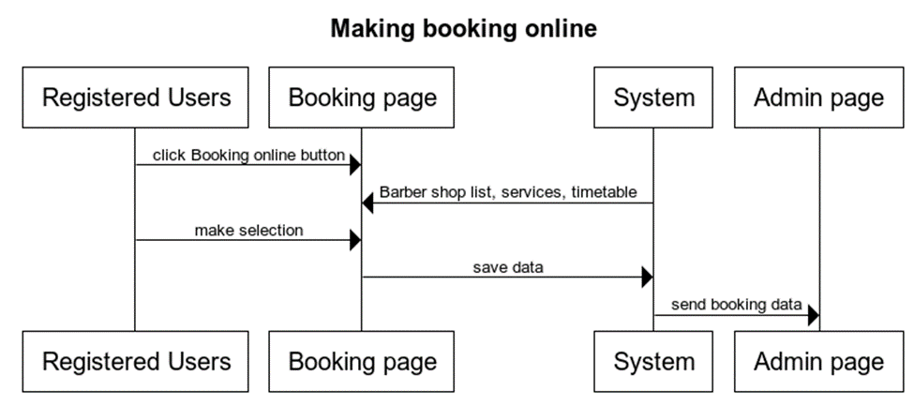

* 1. **Change password**

|  |  |  |
| --- | --- | --- |
| **Author** | Hoang Thien An | |
| **Use Case Name** | Change password | |
| **Actors** | Registered Users | |
| **Description** | Registered Users can change their password | |
|  | **Actor Action** | **System Responses** |
| **Basic Flow** | 1. User click Change password link  3. Change password, click submit | 2. Redirect to Password page, show current password |
| **Alterative flow** |  |  |

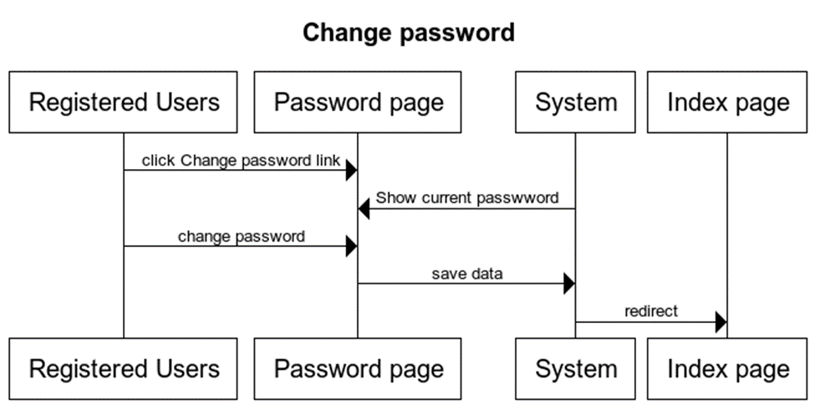

* 1. **Rating stylist**

|  |  |  |
| --- | --- | --- |
| **Author** | Hoang Thien An | |
| **Use Case Name** | Rating stylist | |
| **Actors** | Registered Users | |
| **Description** | Registered Users can rate barbers | |
|  | **Actor Action** | **System Responses** |
| **Basic Flow** |  |  |
| **Alterative flow** |  |  |

* 1. **View Booking detail**

|  |  |  |
| --- | --- | --- |
| **Author** | Hoang Thien An | |
| **Use Case Name** | View booking detail | |
| **Actors** | Registered Users | |
| **Description** | Registered Users can view the booking information in detail | |
|  | **Actor Action** | **System Responses** |
| **Basic Flow** | User click on Booking detail after click complete button in Booking page | Show all info of the booking user has just entered |
| **Alterative flow** |  |  |

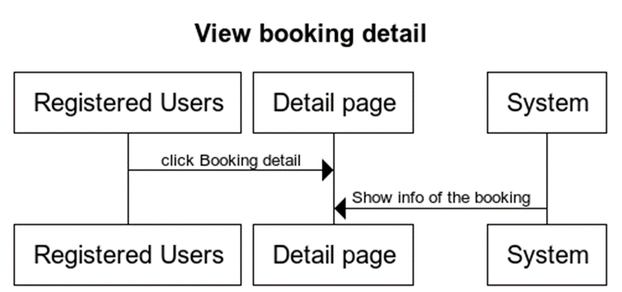

* 1. **View Booking History**

|  |  |  |
| --- | --- | --- |
| **Author** | Hoang Thien An | |
| **Use Case Name** | View booking history | |
| **Actors** | Registered Users | |
| **Description** | Registered Users can view their booking history | |
|  | **Actor Action** | **System Responses** |
| **Basic Flow** | 1. User click on service used history in dropdown list of the phone number | 2. Display all services + booking info that user have used |
| **Alterative flow** |  |  |

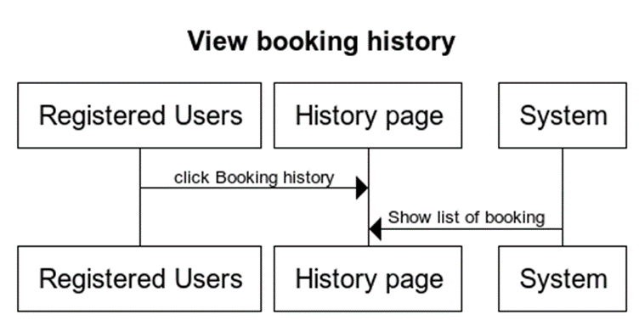

* 1. **Delete booking history**

|  |  |  |
| --- | --- | --- |
| **Author** | Hoang Thien An | |
| **Use Case Name** | Delete booking history | |
| **Actors** | Registered Users | |
| **Description** | Registered Users can delete their booking history if they want | |
|  | **Actor Action** | **System Responses** |
| **Basic Flow** | User click on delete all in page service used history | Delete all services history user used |
| **Alterative flow** |  |  |

* 1. **Add complaint**

|  |  |  |
| --- | --- | --- |
| **Author** | Hoang Thien An | |
| **Use Case Name** | Add complain | |
| **Actors** | Registered Users | |
| **Description** | Registered Users can complain if they unsatisfied with the hairstyle they want | |
|  | **Actor Action** | **System Responses** |
| **Basic Flow** | User can complain in feedback form if they are unsatisfied | The form will send to admin |
| **Alterative flow** |  |  |

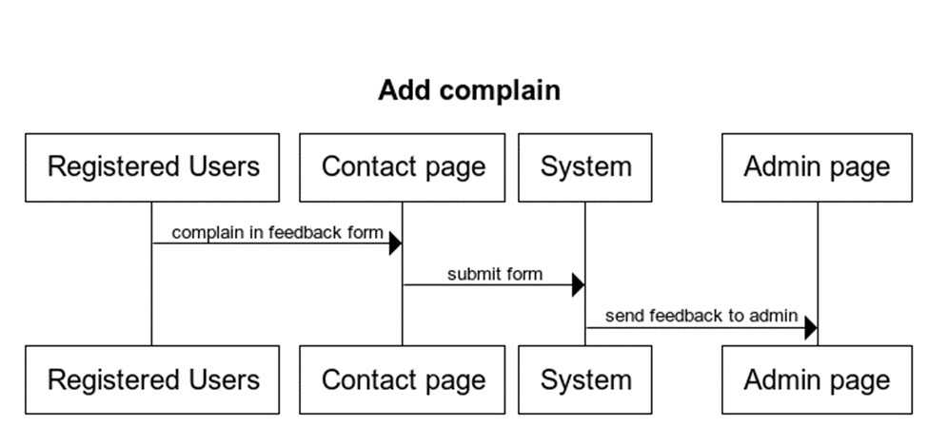

## **Stylist**

* 1. **Check in**

|  |  |  |
| --- | --- | --- |
| **Author** | Le Minh | |
| **Use Case Name** | Check-in | |
| **Actors** | Employee and Manager | |
| **Description** | When the employee came to the shop, and the employee click on button check-in, the manager will click “Yes” to confirm that the employee is there | |
|  | **Actor Action** | **System Responses** |
| **Basic Flow** | 1. The employee click on check-in. 2. The employee click “yes” | 1. The manager go to check-in list to confirm “yes” 2. Add employee to table work day |
| **Alterative flow** | 1. Click “no” | 1. Click “no” |

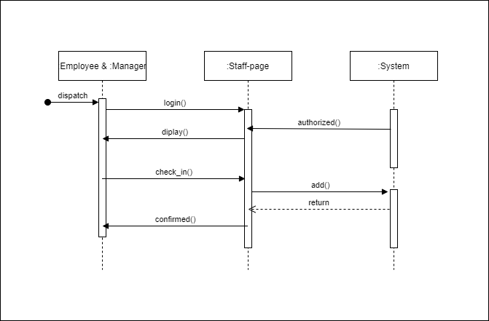

* 1. **Update personal information**

|  |  |  |
| --- | --- | --- |
| **Author** | Le Minh | |
| **Use Case Name** | Update personal information | |
| **Actors** | Employee | |
| **Description** | The employee has change home address , phone number, email | |
|  | **Actor Action** | **System Responses** |
| **Basic Flow** | Step 1: Click on details  Step 3: Click on update  Step 5: Input edit information  Step 6: Confirmed | Step 2: Display all details  Step 4: Show the update form |
| **Alterative flow** |  |  |

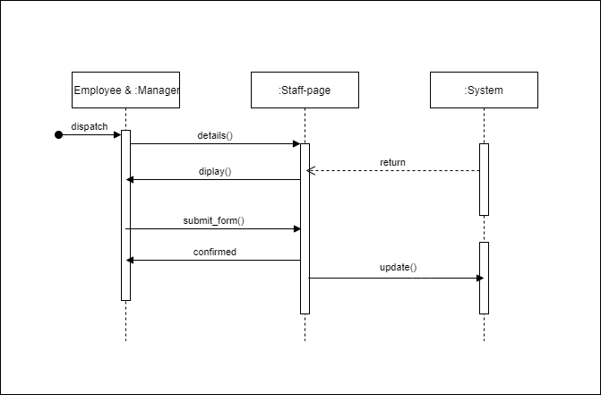

* 1. **Take turn with booking**

|  |  |  |
| --- | --- | --- |
| **Author** | Le Minh | |
| **Use Case Name** | Take turn with booking | |
| **Actors** | Manager | |
| **Description** | The manager will match the employee with the appointment that has been check-in in shop | |
|  | **Actor Action** | **System Responses** |
| **Basic Flow** | Step 1: Click on show waiting list  Step 4: Select employee  Step 5: Click confirm | Step 2: Choose the appointment  Step 3: Show detail appointment and show dropdown employee list  Step 6: Add to Turn table |
| **Alterative flow** |  |  |



* 1. **View employee history turn**

|  |  |  |
| --- | --- | --- |
| **Author** | Le Minh | |
| **Use Case Name** | View employee history turn | |
| **Actors** | Employee | |
| **Description** | The employee can check their turn in a day | |
|  | **Actor Action** | **System Responses** |
| **Basic Flow** | Step 1: Click on details | Step 2: Display all details |
| **Alterative flow** | Step 3: They can check their amount , that they make | Step 4: Click “Home” |

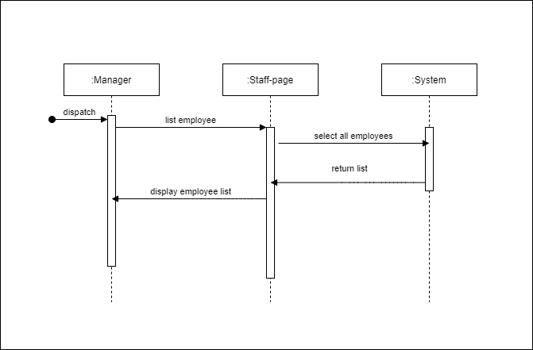

* 1. **View all staff information**

|  |  |  |
| --- | --- | --- |
| **Author** | Le Minh | |
| **Use Case Name** | View all staff information | |
| **Actors** | Manager | |
| **Description** | The manager can view all staffs information in their store, view their salary | |
|  | **Actor Action** | **System Responses** |
| **Basic Flow** | Step 1: Click on employee list button  Step 3: Click on a specific employee | Step 2: Display all employee  Step 4: display employee’s details |
| **Alterative flow** |  |  |

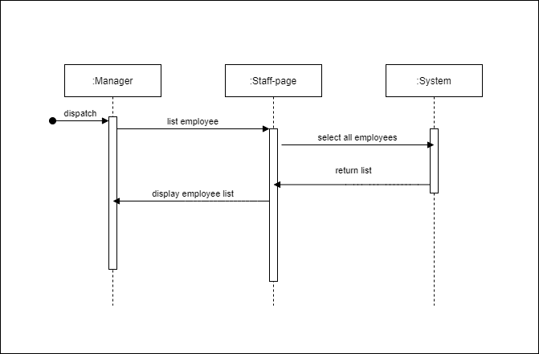

* 1. **View feedback**

|  |  |  |
| --- | --- | --- |
| **Author** | Le Minh | |
| **Use Case Name** | View feedback | |
| **Actors** | Manager | |
| **Description** | The manager can view feedback from customer | |
|  | **Actor Action** | **System Responses** |
| **Basic Flow** | Step 1: Click on feedback list  Step 3: Click on a specific feedback | Step 2: Display all feedback  Step 4: display customer feedback |
| **Alterative flow** |  |  |

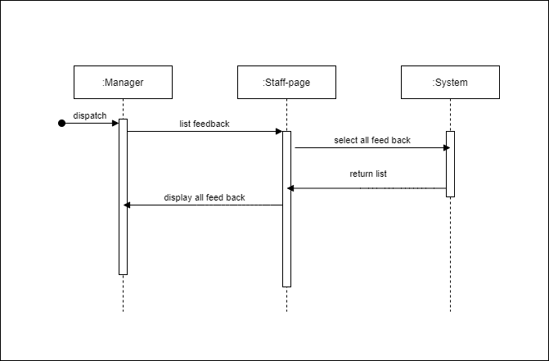

* 1. **Making payment**

|  |  |  |
| --- | --- | --- |
| **Author** | Le Minh | |
| **Use Case Name** | Making payment | |
| **Actors** | Manager, customer | |
| **Description** | The customer after finish their service, they come to front table and make payment | |
|  | **Actor Action** | **System Responses** |
| **Basic Flow** | Step 1: Click on Turn table list  Step 2: Choose the customer appointment  Step 4: Confirm to next step  Step 6: Choose the payment medthod and click confirm to next step  Step 8: Confirm | Step 3: Display information of the appointment  Step 5: Display form of payment method  Step 7: Display all payment detail |
| **Alterative flow** | Step 9: Click “No” | Step 10: Go back to turn table list |

## 

## **Administrator**

* 1. **Login**

|  |  |  |
| --- | --- | --- |
| **Author** | Nguyễn Minh Thoại | |
| **Use Case Name** | Login | |
| **Actors** | Admin | |
| **Description** | Admin log in with their registered email and password. | |
|  | **Actor Actions** | **System Responses** |
| **Basic flow** | 1. Input email and password and clicks on Submit button | 2. System check email and password [Exception 1]  3. System tracks the user’s information and display Home page |
| **Exception** | [Exception 1]  1. Actor left the Email blank  2. Actor left the Password blank  3. Actor inputs wrong email or password | Display error message:  - “Email can not be blank”  - “Password can not be blank”  - “Wrong email or Password” |

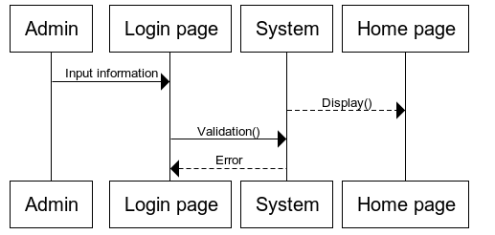

* 1. **New Employee**

|  |  |  |
| --- | --- | --- |
| **Author** | Nguyễn Minh Thoại | |
| **Use Case Name** | New employee | |
| **Actors** | Admin | |
| **Description** | Admin click button new employee to create new employee | |
| **Requirements** | Login as admin | |
|  | **Actor Actions** | **System Responses** |
| **Basic flow** | 1. Actor input: phone number, password, first name, last name, role, salon id, thumbnail, is active, nickname, email, home address, date of birth, is available, is online booking available | 2. System check the information  [Exception 1]  3. Create new employee to data in employee table |
| **Exception** | [Exception 1]  1. Actor left all field blank | Display error message:  - all field “can not blank” |

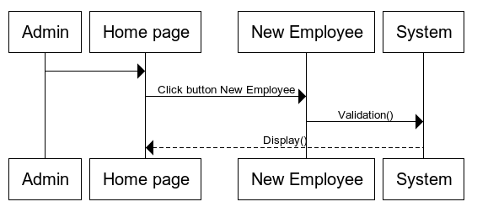

* 1. **View Employee**

|  |  |  |
| --- | --- | --- |
| **Author** | Nguyễn Minh Thoại | |
| **Use Case Name** | View employee | |
| **Actors** | Admin | |
| **Description** | Admin clicks View employee button to view employee information | |
| **Requirements** | Login as admin | |
|  | **Actor Actions** | **System Responses** |
| **Basic flow** | 1. Actor click view employee | 2. Display employee information |
| **Exception** |  |  |

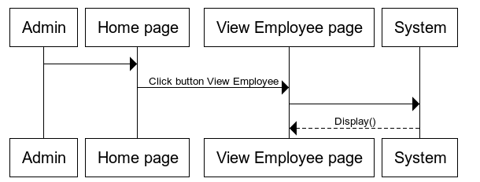

* 1. **Edit employee**

|  |  |  |
| --- | --- | --- |
| **Author** | Nguyễn Minh Thoại | |
| **Use Case Name** | Edit employee | |
| **Actors** | Admin | |
| **Description** | Admins want to update existed employee’s information | |
| **Requirements** | Login as admin | |
|  | **Actor Actions** | **System Responses** |
| **Basic flow** | 1. Actor input information to input fields: phone number, password, first name, last name, role, salon id, thumbnail, is active, nickname, email, home address, date of birth, is available, is online booking available | 2. System check the information  [Exception 1]  3. Update new employee information in table. |
| **Exception** | [Exception 1]  1. Actor left all field blank | Display error message:  - all field “can not blank” |

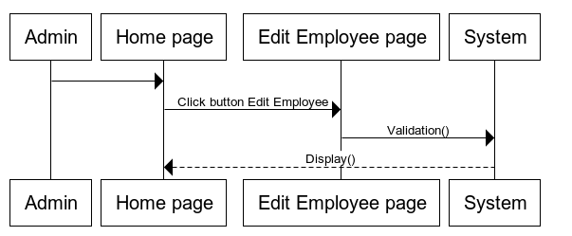

* 1. **Delete Employee**

|  |  |  |
| --- | --- | --- |
| **Author** | Nguyễn Minh Thoại | |
| **Use Case Name** | Edit employee | |
| **Actors** | Admin | |
| **Description** | Admins want to delete existed employee | |
| **Requirements** | Login as admin | |
|  | **Actor Actions** | **System Responses** |
| **Basic flow** | 1. Actor click button delete | 2. System delete employee’s information |
| **Exception** |  |  |

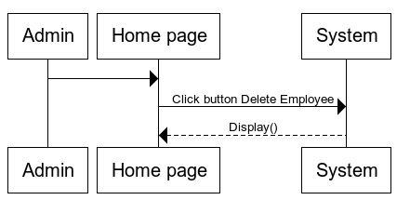

* 1. **Add new salon**

|  |  |  |
| --- | --- | --- |
| **Author** | Nguyễn Minh Thoại | |
| **Use Case Name** | New salon | |
| **Actors** | Admin | |
| **Description** | Admin click button new salon to create new salon | |
| **Requirements** | Login as admin | |
|  | **Actor Actions** | **System Responses** |
| **Basic flow** | 1. Actor input: salon name, address, email, thumbnail, phone number, opening houre, minute in one time slot, í available for booking, number of turn in one time slot is opened, is car parking available | 2. System check the information  [Exception 1]  3. Create new salon to data in salon table |
| **Exception** | [Exception 1]  1. Actor left all field blank | Display error message:  - all field “can not blank” |

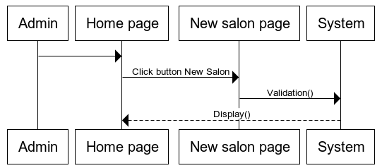

* 1. **Update Salon**

|  |  |  |
| --- | --- | --- |
| **Author** | Nguyễn Minh Thoại | |
| **Use Case Name** | Update salon | |
| **Actors** | Admin | |
| **Description** | Admins want to update existed salon’s information | |
| **Requirements** | Login as admin | |
|  | **Actor Actions** | **System Responses** |
| **Basic flow** | 1. Actor input information to input fields: salon name, address, email, thumbnail, phone number, opening houre, minute in one time slot, í available for booking, number of turn in one time slot is opened, is car parking available | 2. System check the information  [Exception 1]  3. 3. Update new salon information in table. |
| **Exception** | [Exception 1]  1. Actor left all field blank | Display error message:  - all field “can not blank” |

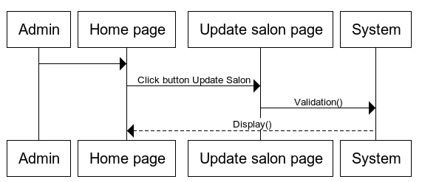

***Task Sheet 2***

|  |  |  |  |  |  |  |  |
| --- | --- | --- | --- | --- | --- | --- | --- |
| **Project Ref. No.:**  Barberia | | **Project**  **Title:** | **Activity Prepared By:** | **Date of Preparation of Activity Plan:** | | | |
| **Sr.No.** | **Task** | **Actual Start Date** | **Actual Days** | **Team Mate Names** | **Status** |
| 1 | Use Case | **BARBERIA** | **Hoang Thien An** | 18/07/2021 | 5 | Le Minh | 100% |
| 2 | Table Relationship Diagram | 18/07/2021 | 5 | Le Minh | 100% |
| 3 | Data Flow Diagram | 18/07/2021 | 5 | Hoang Thien An | 100% |
| 4 | Sequence Diagram | 18/07/2021 | 5 | All members | 100% |

Review 3

GUI Design

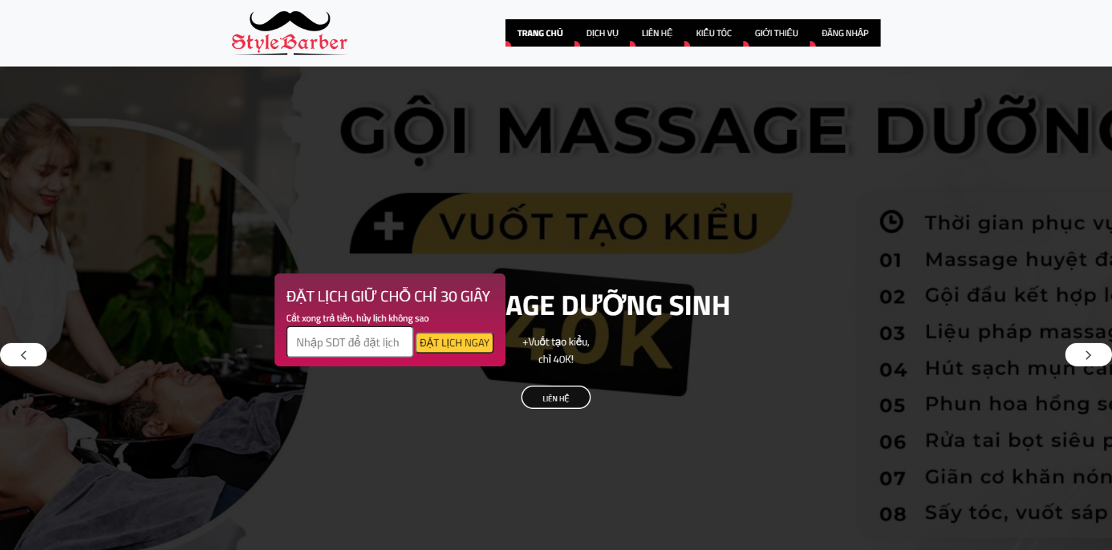For Customer  
I/ Home page:

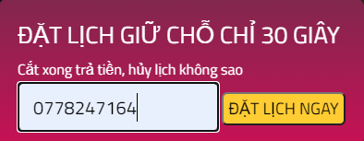II/ Booking:

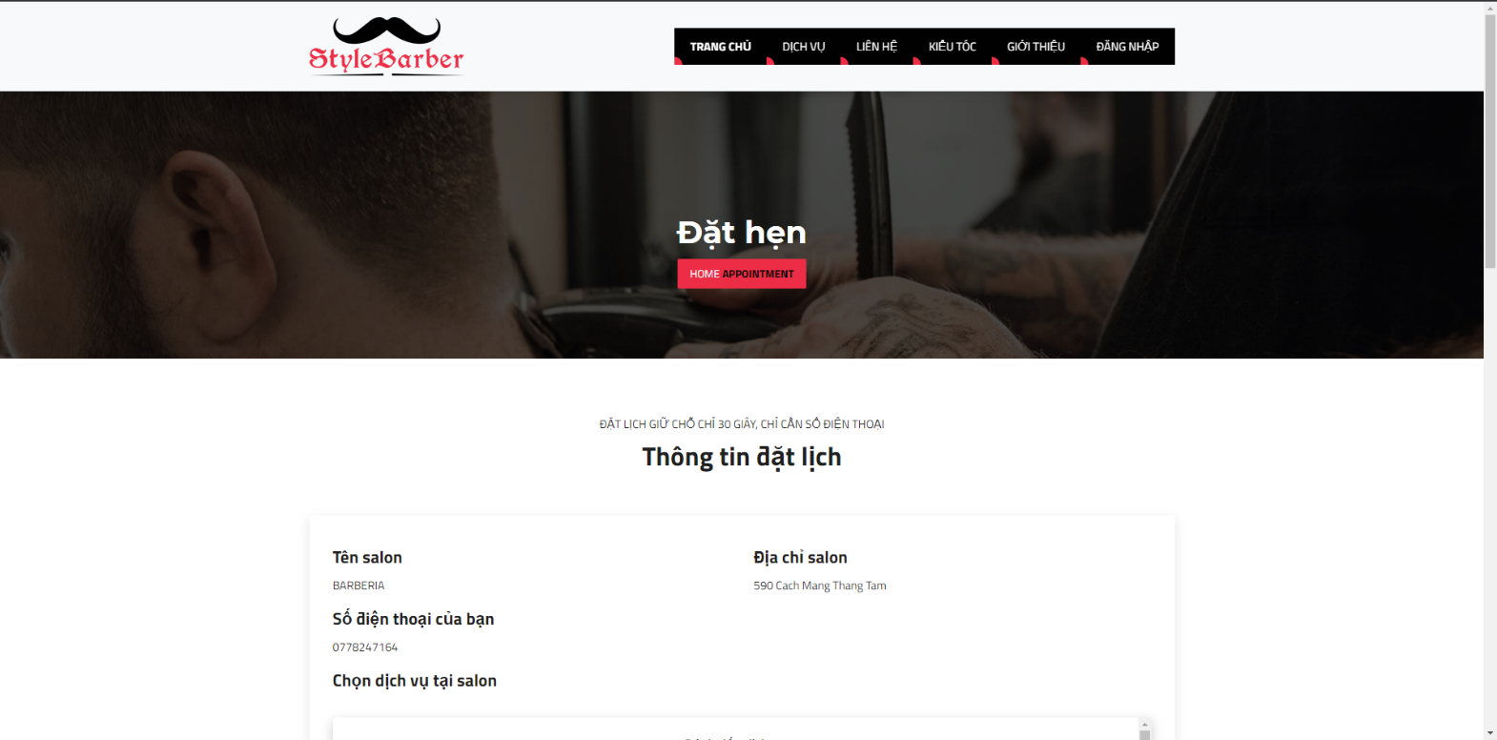

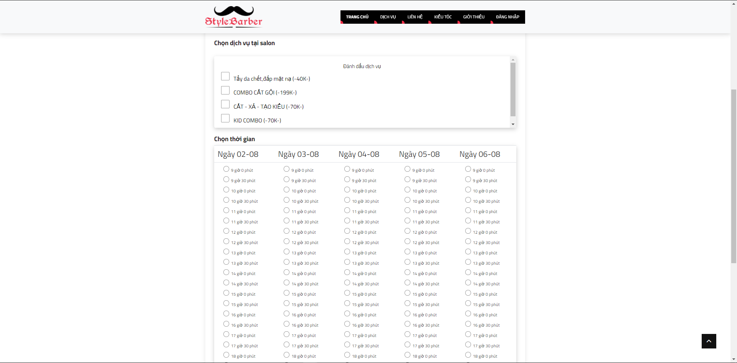

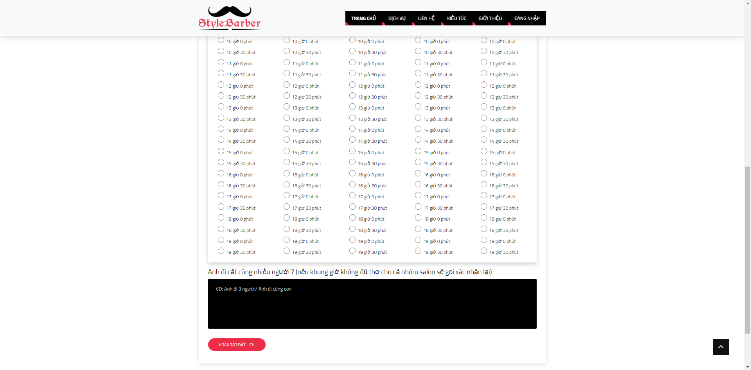

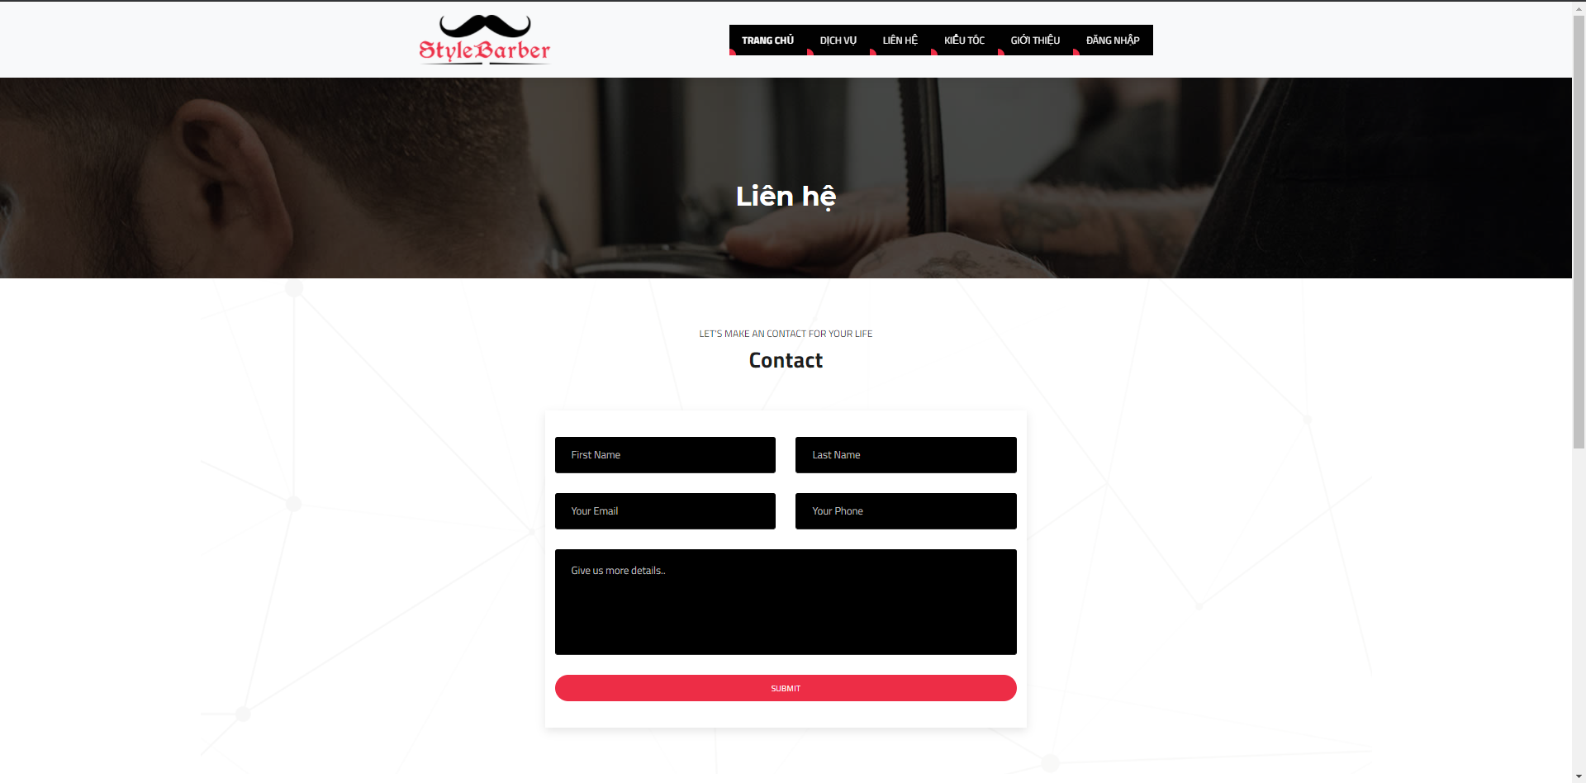III/ Contact:

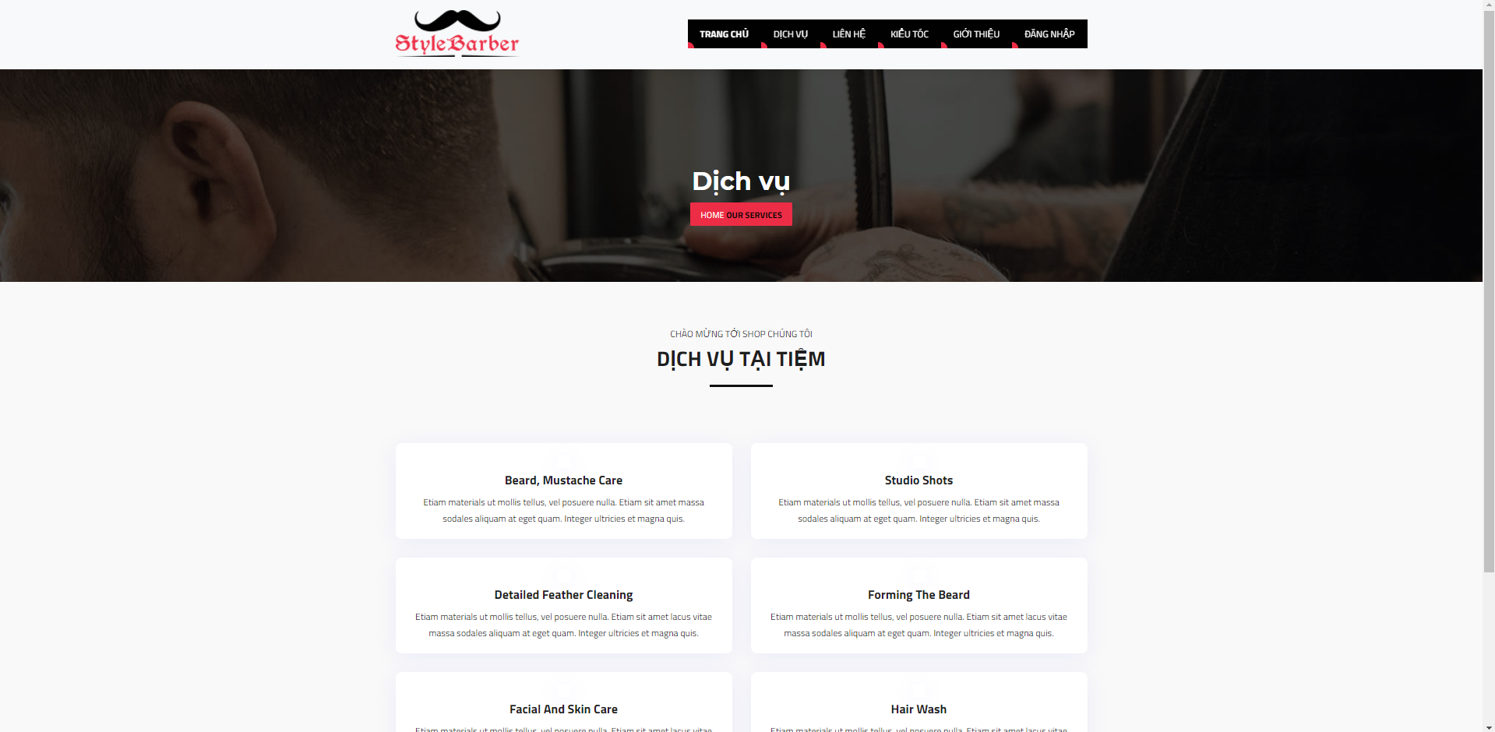IV/ Services:

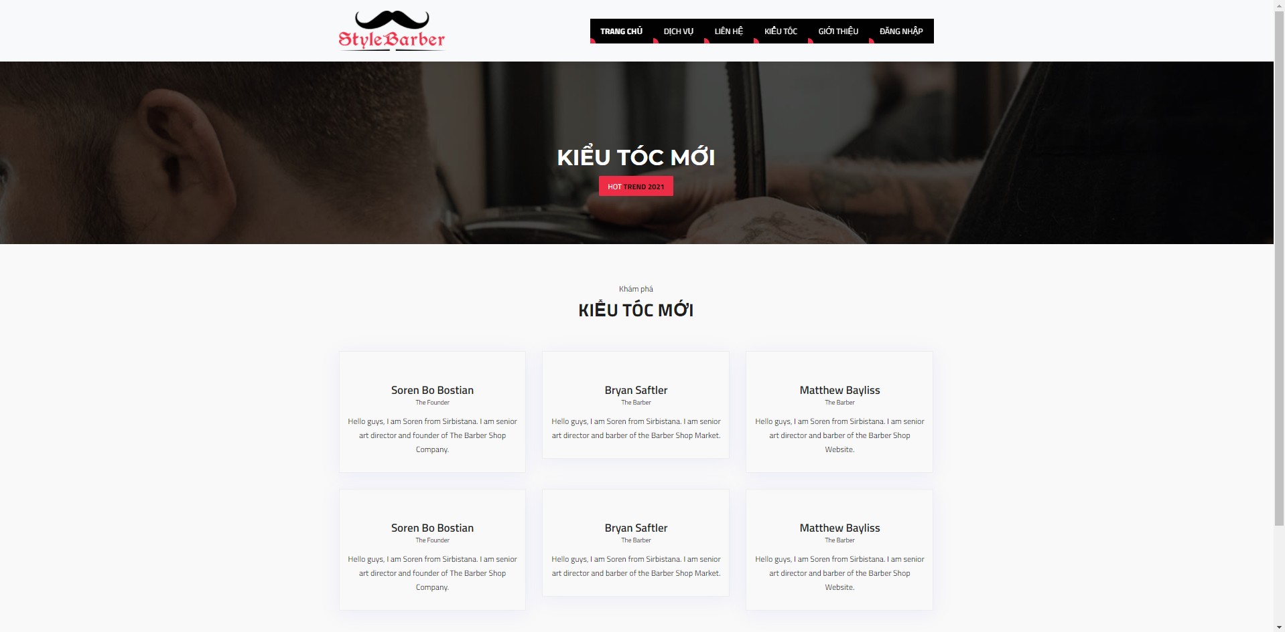V/ Hair styles:

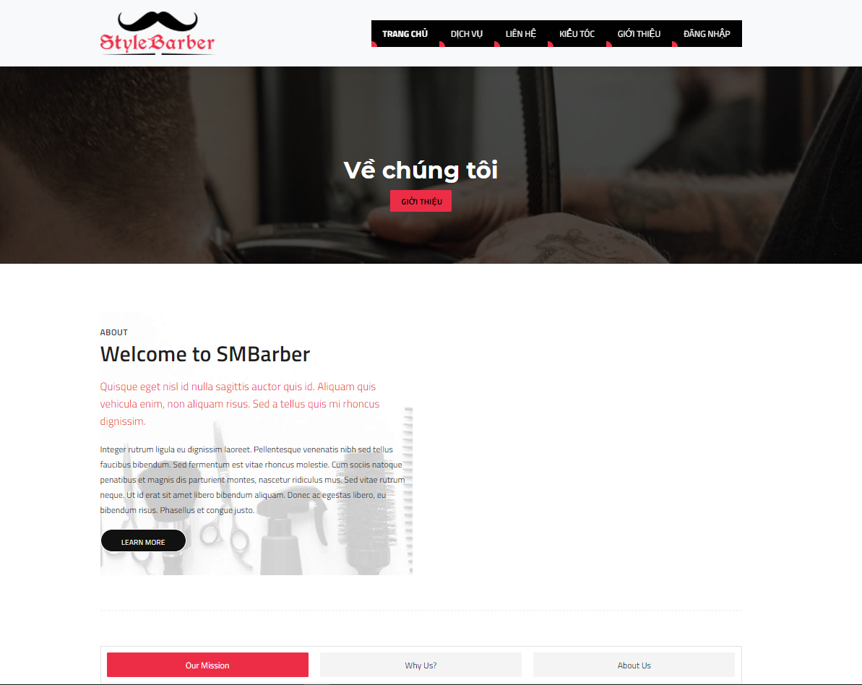VI/ About us:

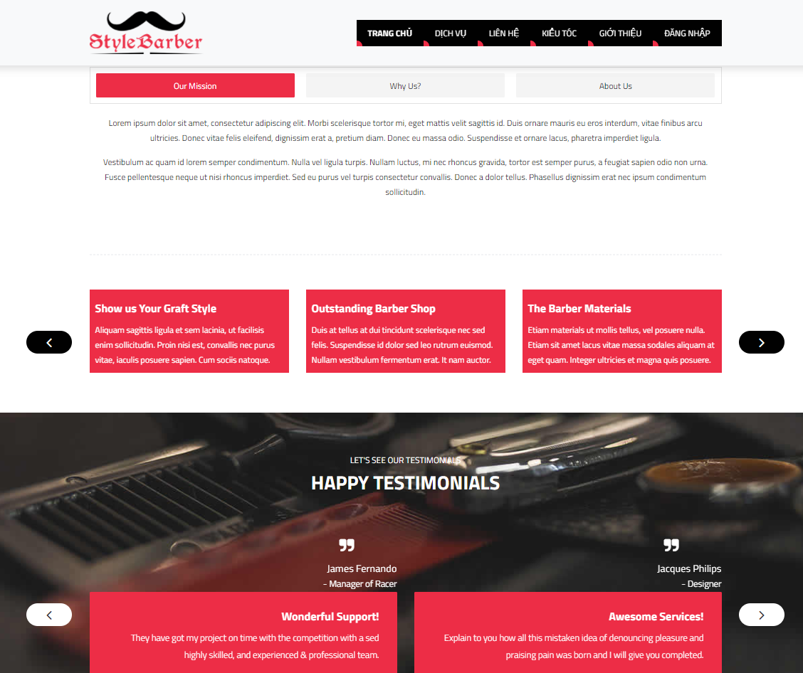

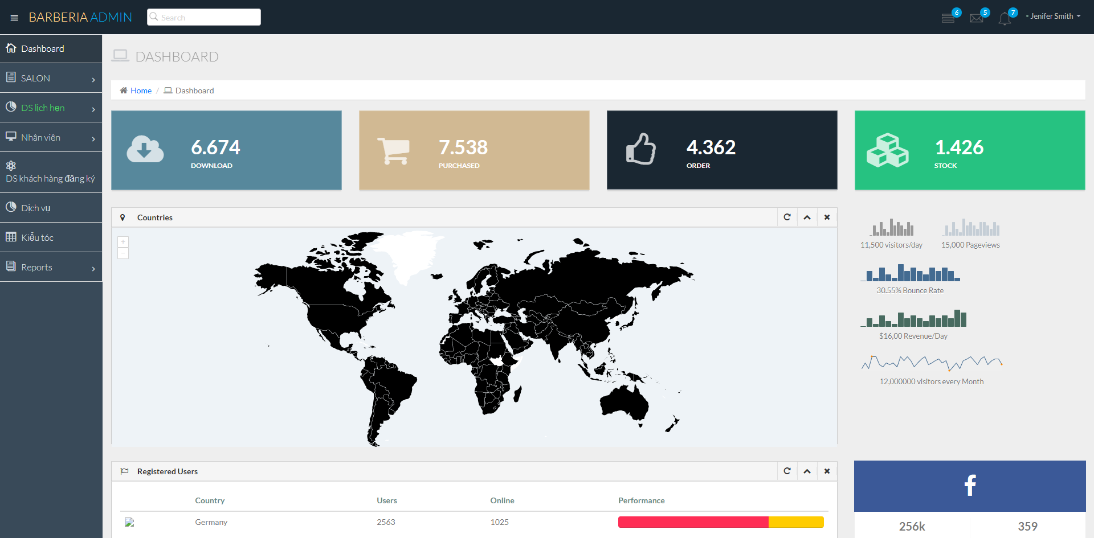For Admin  
I/ Dashboard:

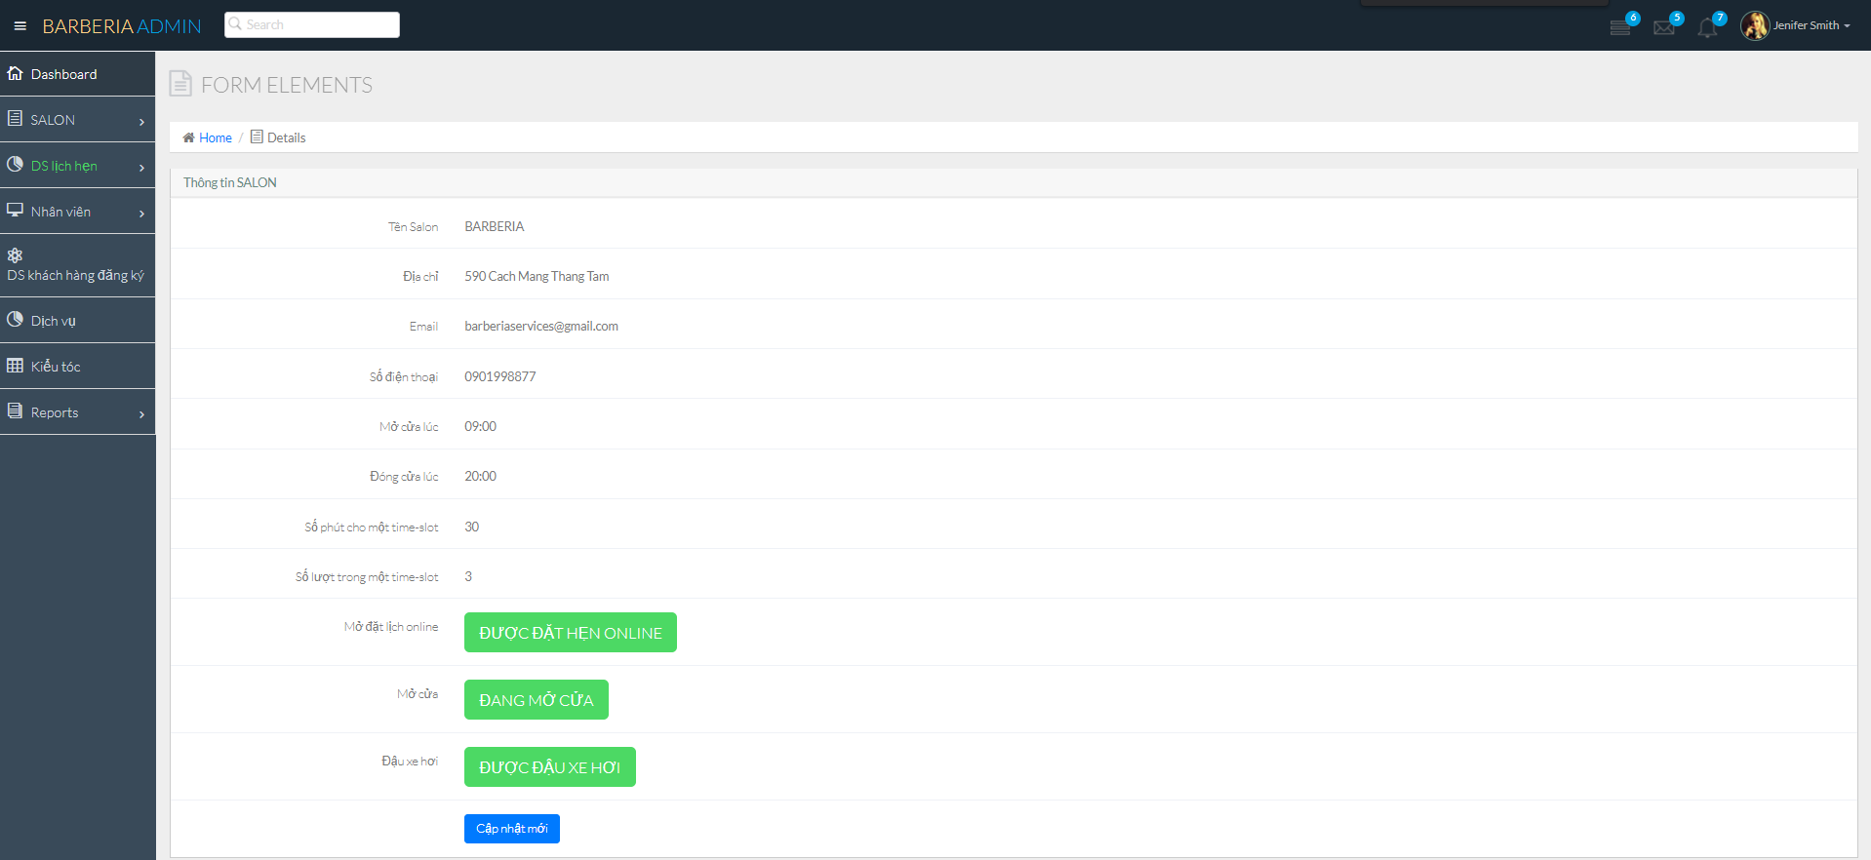II/ Salon info / Edit info:

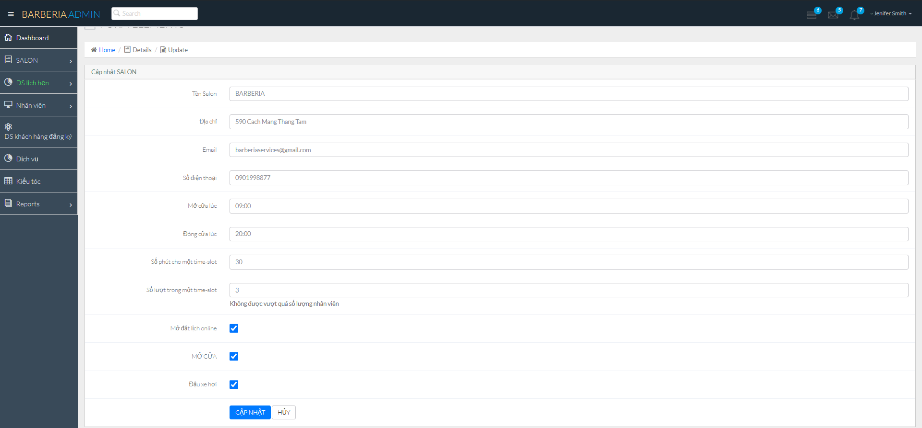

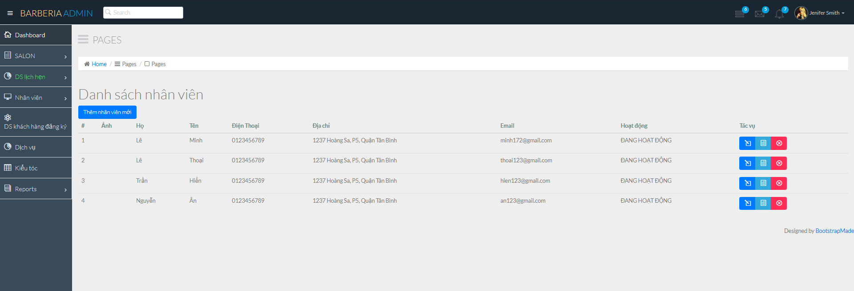III/ Employee list:

IV/ Add new employee:

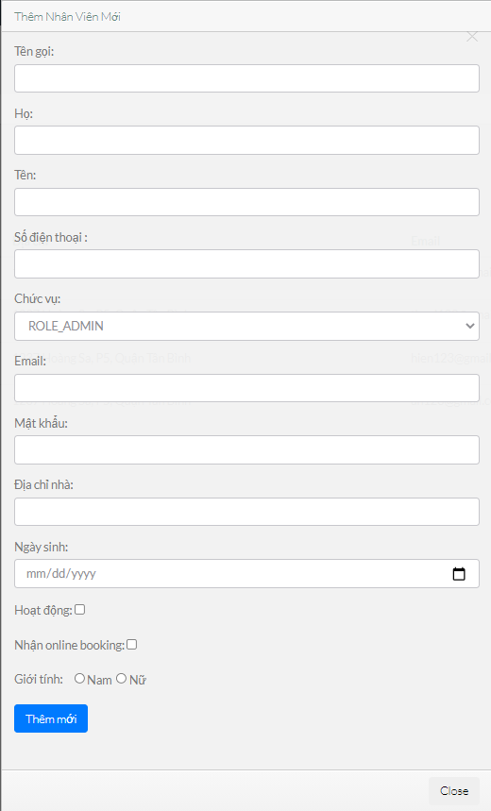

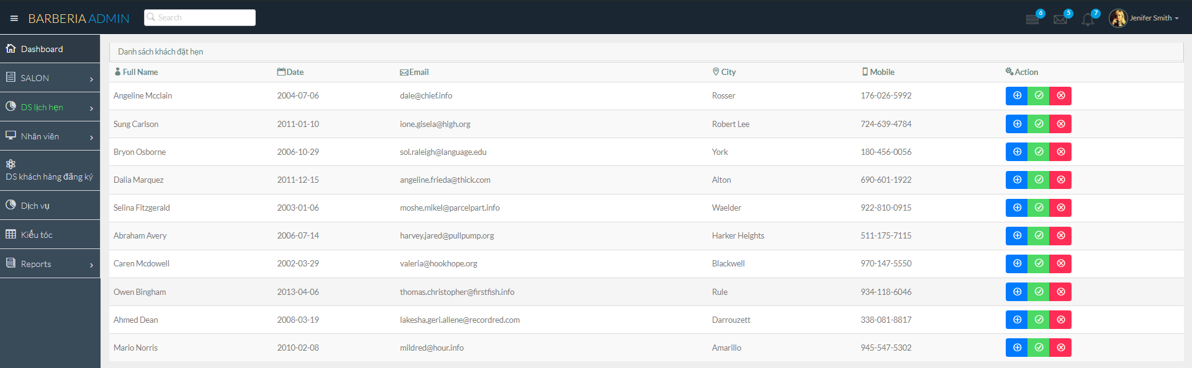V/ Booking list:

***Task Sheet 3***

|  |  |  |  |  |  |  |  |
| --- | --- | --- | --- | --- | --- | --- | --- |
| **Project Ref. No.:**  Barberia | | **Project**  Title: | Activity Prepared By: | Date of Preparation of Activity Plan: | | | |
| Sr.No. | Task | Actual Start Date | Actual Days | Team Mate Names | Status |
| 1 | Homepage | BARBERIA | Hoang Thien An | 31/07/2021 | 1 | Hoang Thien An | 100% |
| 2 | Booking | 31/07/2021 | 1 | 100% |
| 3 | Contact | 31/07/2021 | 1 | Vinh Hien | 100% |
| 4 | Services | 31/07/2021 | 1 | 100% |
| 5 | Hair styles | 31/07/2021 | 1 | Minh Thoai | 100% |
| 6 | About us | 31/07/2021 | 1 | 100% |
| 7 | Dashboard | 31/07/2021 | 1 | Le Minh | 100% |
| 8 | Salon info | 31/07/2021 | 1 | 100% |
| 9 | Employee list / add new employee | 31/07/2021 | 1 | 100% |
| 10 | Booking list | 31/07/2021 | 1 | 100% |